99 percentile graphs

|  |  |
| --- | --- |
| TCP (Max / Avg) | Homa+Udp (Max / Avg) |
| 2.25 Gbit/s  928.87 Mbit/s | 782.67 Mbit/s  318.39 Mbit/s |

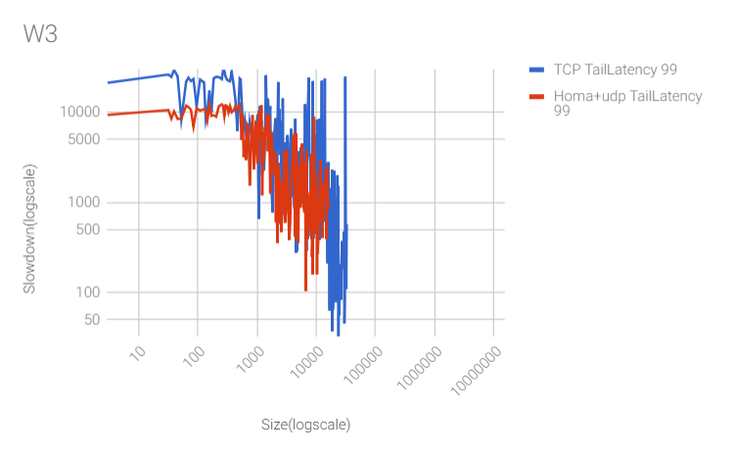

|  |  |
| --- | --- |
| TCP (Max / Avg) | Homa+Udp (Max / Avg) |
| 8.64 Gbit/s  3.65 Gbit/s | 1.50 Gbit/s  544.00 Mbit/s |

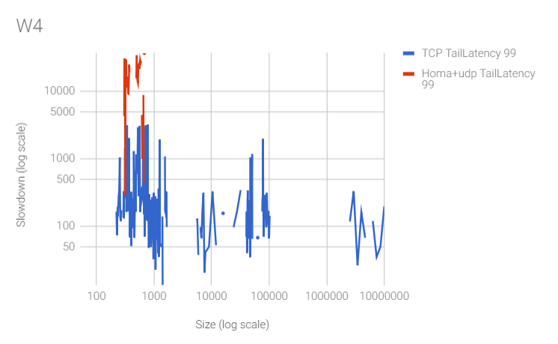

|  |  |
| --- | --- |
| TCP (Max / Avg) | Homa+Udp (Max / Avg) |
| 9.61 Gbit/s  3.74 Gbit/s | 1.36 Gbit/s  531.66 Mbit/s |

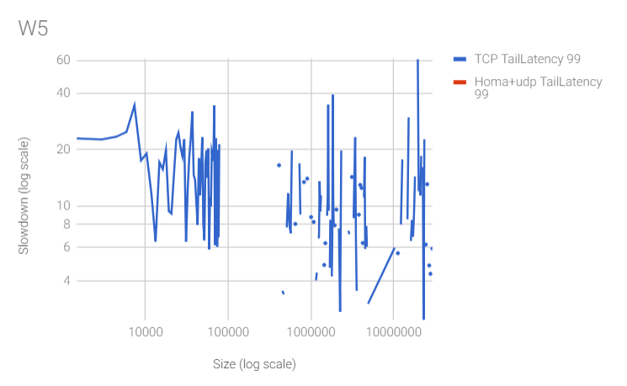

Both 90 & 99 Percentile graphs

|  |  |
| --- | --- |
| TCP (Max / Avg) | Homa+Udp (Max / Avg) |
| 2.25 Gbit/s  928.87 Mbit/s | 782.67 Mbit/s  318.39 Mbit/s |

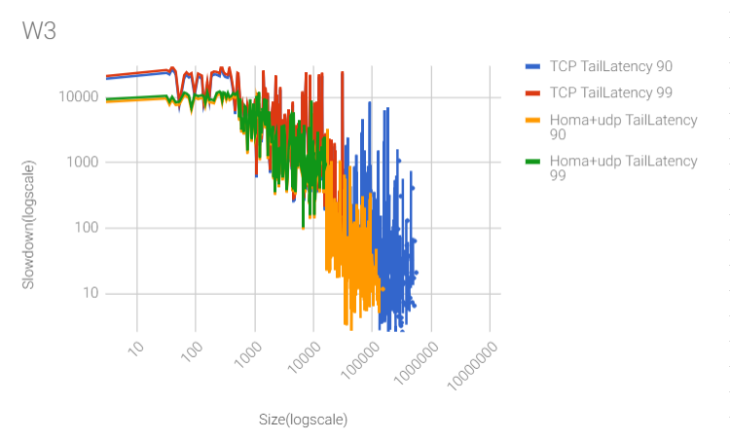

|  |  |
| --- | --- |
| TCP (Max / Avg) | Homa+Udp (Max / Avg) |
| 8.64 Gbit/s  3.65 Gbit/s | 1.50 Gbit/s  544.00 Mbit/s |

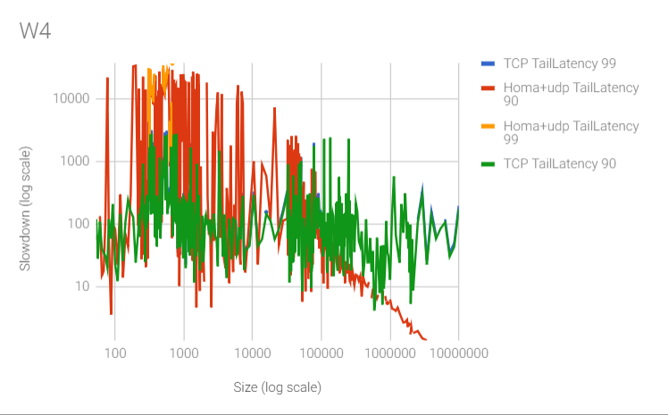

|  |  |
| --- | --- |
| TCP (Max / Avg) | Homa+Udp (Max / Avg) |
| 9.61 Gbit/s  3.74 Gbit/s | 1.36 Gbit/s  531.66 Mbit/s |

